**I Am A Bug!**

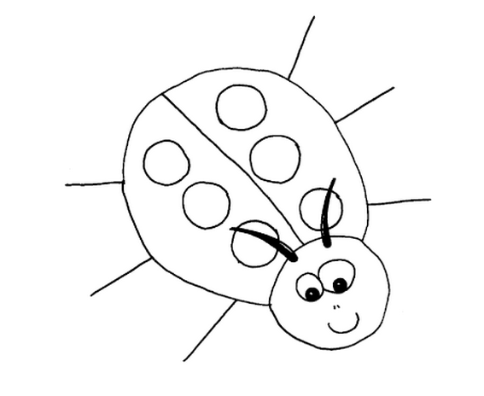  
为了使我们的工作更有趣，当我们的软件中有一个问题的时候，我们叫它 bug。

I encourage people working on software projects to have a very broad concept of what a bug is. I like to define a bug as any concern someone has about the project.Many people try to use a specific definition: one is to say that a bug is a defect, problem, or anomaly in the software injected into some artifact (requirements, design, code, and so on) either by omission or by fault, characterized by a failure in the software. But a bug is‘n always caused by a defect or an error.sometimes it is just an emergent behavior. This definition limits what is considered a bug, so important concerns may go unreported."

我比较支持在软件工程中给予BUG以更广的定义，我喜欢把它定义为和项目相关所有事物。大部分人定义bug使用特定定义，比如bug是缺陷，问题，软件开发交付件（需求，设计，代码等等）中被植入的异常，或是被弄错的或者被忽略的，以软件故障为呈现。但是不一定会因为缺陷或者错误而导致的，有时候它只是意外行为，这种狭义的定义被认为是一个bug，因为重要的关注点是没有被定义进去的。

**Here are some**[**people**](http://www.amibug.com/iamabug/p02.html)**who care about me.**

**这些都是关注我的人**

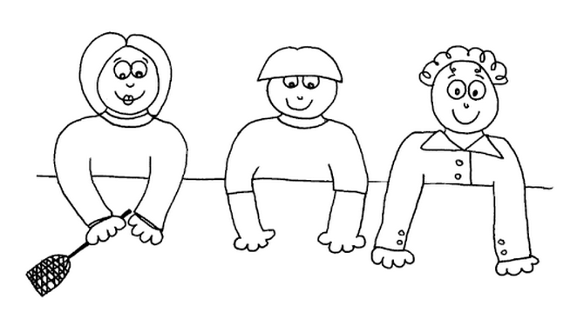

Audrey is our [**SQA Director**](http://www.amibug.com/iamabug/p02.html)—her team finds the bugs!

Audrey 是我们的SQA主管--他的团队找到bug！

Yves-Alain is our [**Development Lead**](http://www.amibug.com/iamabug/p02.html)—he makes sure bugs don'te get into our software. But if they do, his team gets rid of them!

Yves-Alain 是我们的开发主管，他保证软件中不引入bug，但如果有bug引入了，他的团队处理他们。  
  
Oliver is our [**Product Manager**](http://www.amibug.com/iamabug/p02.html)—he works with our customers to find out what our programs should do! Oliver helps us decide which bugs to get rid of and which bugs to keep!

Oliver是我们的产品经理，他和客户一起确定我们程序需要做的事情。Oliver帮助我们确定哪些bug需要处理，哪些不需要。

**There are three significant perspectives necessary on the triage team to make a decision. These perspectives are provided by the SQA director, the development lead, and the product manager.**

**在这种做决策的团队中三个不同的视角是非常有必要的，这些角色是SQA主管，开发主管，产品经理。**

In a triage meeting, the triage team decides whether to fix a bug or not fix a bug. Deciding to keep a bug makes the bug part of the product. This decision is usually made when fixing a bug could do more damage than not fixing it. Keeping a bug makes it part of the product&#8212;usually customers must be encouraged to avoid or ignore it.<br><br>A bug triage meeting should involve a small, effective group of people who are qualified to make decisions largely on their own. A bad bug triage meeting involves a large, ineffective group of people that keeps calling more people into the room because they cannot make a decision. Even a good triage team may sometimes need additional input, but very rarely should they pass the responsibility of making the decision of whether to keep or fix a bug to someone else.

在这个决策会议中，决定bug是否需要修复，决定保留这个bug不修复（遗留问题），这种决定通常是修复这个bug容易对软件引发破坏，决定把这些bug遗留在产品中，通常是客户容易忽视和不会碰到的情况。一个决策团队应该是小型的，有效的团队，

|  |  |
| --- | --- |
|  | "</center>The SQA director is the advocate for the QA perspective. The triage team looks at a bug using objective information provided by the SQA director. Then the development lead and product manager discuss the information and reach a decision. The SQA director does not vote on whether the bug should be fixed or not&#8212;she should be impartial.", |
|  | "</center>The development lead is the advocate for the developers. His job is to assess the technical risk of fixing or not fixing a bug.", |
|  | "</center>The product manager is the advocate for the customer. His job is to assess the business risk of fixing or not fixing a bug.<br><br>If the product manager and development lead are always arguing about which bugs to fix and which bugs to keep, the team is ineffective. Occasional arguments are normal, but usually the two should be in agreement. In the rare case that they cannot agree on whether to fix or keep a bug, I usually err on the side of the product manager because he is in the best position to know the needs of the customer |